SECURING HOME ROBBERY DETECTION DEVICE
PADEGELA PRANAY KUMAR YADAV  Department of Electronics and Communication Engineering  Institute of Aeronautical Engineering  Hyderabad, Telangana  pranaykumaryadavpadegela@gmail.com | RUDRAPREETH.K  Department of Electronics and Communication Engineering  Institute of Aeronautical Engineering  Hyderabad, Telangana  20951a04e1@iare.ac.in | Gorla Hampika  Department of Electronics and Communication Engineering  Institute of Aeronautical Engineering  Hyderabad, Telangana  hampika.g@iare.ac.in

Abstract— — Most major cities are highly endangered from thefts in a range of ways, such chain robberies, robberies committed by persons inside stores, and home invasions. These residential crimes take place by breaking in via the locked doors. It is sometimes possible to prevent murder of an owner during a late-night heist by having cops patrol the area at night and taking other security measures, according to state police. However, this strategy can't stop home invasion robberies because authorities are unable to search every single house. A number of modules, including Auto-Configuration and Management, Communication Protocol, Auto-monitoring and Control, and Objects Security Systems, are included in the proposed generic framework. The proposed generic framework comprises various modules such as Auto-Configuration and Management, Communication Protocol, auto-monitoring and Control, and Objects Access Control. The architecture of the new generic framework and functionality of various modules in the framework are also presented. The proposed generic framework is helpful for making every house as smart house to increase the comfort of inhabitants with security. Each of the components of generic framework is robust in nature in providing services at any time. The components of smart home system are designed to take care of various issues such as scalability, interoperability, device adaptability, security and privacy. The proposed generic framework is designed to work on all vendor boards and variants of Linux and Windows operating system.
Keywords—Raspberry Pi, spy cam, Door Sensor, LCD, GSM, GPS, Buzzer.

INTRODUCTION
Now a days many robberies are taking place mainly the robberies are of four types in that the main robberies are gome robberies they are also call as HB which also called as house breaking . In that HB they are mainly two types one is HB(D) it means the robbery which took place by breaking the house in day time and the second one is HB(N) which means the house braking robberies which are taking place during. During the robberies many of the precious thing(important ) like Gold, money and many other are getting stolen . In some areas they are hurting and killing the people during robbery. By using our device it directly connects to the police(100) and it also alerts us.
Smart home security system was designed by Aman sharma, Anjana Goen in 2018. The whole project was good but the limitations in their project are it is to costly and very complex to design and the main disadvantage is every one cannot understand it.
IOT based technology for smart home security A generic framework in2017. The whole is good but it has some limitations we can operate the device from long ranges, and after this also there are many robberies are taking place.[1]
Research of intelligence home security surveillance system Based on ZigBee. There is no product based upon this it’s just an research.
Like many proects are there which are very complex to design and they are very much costly. And main motto is to make the things which can be accessed by every one. But many many cannot be used by illiterate’s.

Proposed device
This system advances the existing smart door lock technology and enhances the security features, thereby proving to be a significant progress for the main business. Our suggested work includes remarkable models of the various components of the process, including the power supply unit, the door sensor detection unit, the camera, system locking component, startup strategy, monitoring, alarm component, and indication..The method's block diagram is shown in the example below (see Fig. 1)
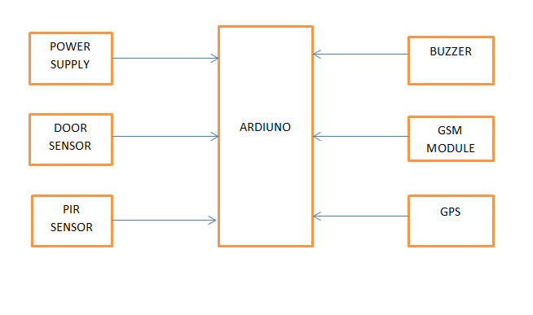
Fig 1: BLOCK DIAGRAM
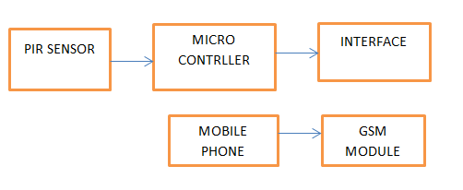
Fig 2: FLOW CHART
This system's hardware components include a power supply, an Arduino UNO, key sensors, an LCD, a buzzer, and LEDs that communicate with the program. Embedded Linux is the software application in use.
The technology quickly locks the car door after detecting the presence of home security in closed homes. As a result, the strategy reduces theft, the number of street robberies, and future fatalities related to device use. An effective association is provided to create the intelligent procedure for house switch, which will expose irrelevant opening door parameters in the middle of a regular time period and may deliver this benefit to the base unit. In the future, I'd like to offer a plan that will fully integrate base communication skills and station by using GSM and changing one of each of the style parameters.
[2].
This approach is also crucial to consider the security from a few protection indicators when utilizing outdoor men and women by using unidentified touching nearby doors.
[9]. A liquid crystal show display may be installed inside the entrance to serve as a signal for the reason pressure along with everyone inside the property. The microcontroller shown in (see Fig. 2). The Arduino organizational structure can be used to continue purchasing output from the vibration sensor and door sensor modules. Additionally, the plan appears to be working as of right now, and the sensor may immediately inform the processor of a suitable voltage. [10]. This reality forces the technique to stop the engine and send a notice to the users. The code is written using the Linux operating system, which is the ecosystem for creating laptop programs. It is then collected, created into a hex file, and loaded onto the controller. The proposed procedure's simulation setup has been validated. (see Fig. 2).
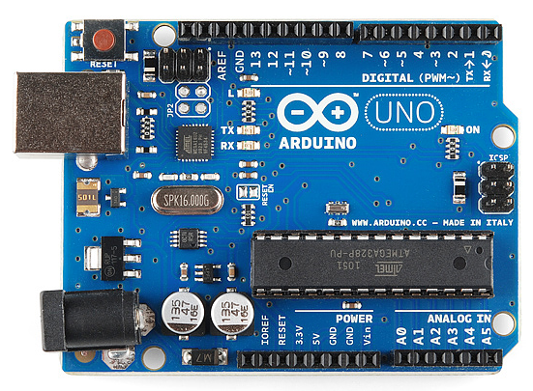
Fig 3: Arduino uno .

Components Specifications
In this section we explained the entire hardware of the SECURING HOME ROBBERY DETECTION DEVICE (Seen Fig.2).

ARDUINO
It is a microcontroller board based on ATmega328p. This has 14 digital pins which are input and output pins. IN that 6 pins are used as PWM (pulse width modulation) output.
The major parts of the Arduino are:
- USB connector
- Power port
- Microcontroller
- Analog input pins
- Digital pins
- Reset switch
- Crystal oscillator
- USB interface chip
- TX RX LEDs

Monitoring Unit:

The machinery that transforms physical quantities into electrical impulses is known as a sensor. The list of sensor types utilised by this system is described below. [8].

i. Obstacle sensors are used to detect objects outside of the vehicle.
ii. Door sensors are used to determine the state of doors.
iii. Vibration sensors are used to identify unidentified human touches.

BUZZER:
A buzzer is a machine that makes beeping sounds. It needs 5 volts DC and is connected to a BC547 transistor to increase the low current to a level that is sufficient for amplification. The device that this project uses to inform users when the intruder enters the room.
LCD
Displays with crystallized liquid Greek letters, all alphabets, unique characters, and mathematical symbols are displayed using LCD technology, which goes by another name. Hitachi's HD44780 controller was employed in the

GSM
Wireless sensor technology for communication systems is one of the most well-liked and pervasive technologies available today. with minimal costs is Global System's for Mobile Communication (GSM). It can communicate fully duplex with an Arduino at a 9600 baud rate. The AT instructions are the foundation of this technology. When intruder enters into the room it initializes the call. And alerts the user.

GPS
In order to determine the location, the Global Positioning System (GPS) is used. There is no need for a phone or the internet. This module can simply interface with an Arduino microcontroller and is compatible with TTL logic. The GPS system detects the location parameters when a sensor is activated and sends them to an Arduino microcontroller.

Spy cam
A webcam is a digital camera that streams or transmits real-time video. to or through a computer to a PC network. The term "webcam" (a clipped compound) can also be used to refer to a video camera that is regularly linked to the internet for an extended period of time rather than for a single session, typically providing a view for anyone who visits its website online. Webcams typically contain a lens, a photo sensor, support electronics, and one or sometimes two sound microphones.

Future Scope:
Smart locks, which can be operated by cellphones, also use AI. Artificial intelligence (AI)-enabled smart locks have many security advantages, including a reduced reliance on physical keys for access, temporary access for visitors, and regular video broadcasts of people ringing the doorbell. The smart home ecosystems of Google, Samsung, and Amazon can accommodate biometric door locks from Kwikset, August, and Samsung.
Residential households are becoming more and more "smart," still analysts predicting residential robberies estimated count is top 300 million in 2023. A rise in new security concerns is anticipated as the market for smart homes expands. Wirelessly connected gadgets are more susceptible to cyber-attacks. Therefore, protecting connected devices from security risks and weaknesses is crucial to gaining homeowners' trust and boosting the sale of smart home technology. For instance, the Maria IoT botnet took over more than 600,000 smart home devices globally in 2016, including security cameras, routers, and air quality monitors. This led to a significant rerouting of web traffic 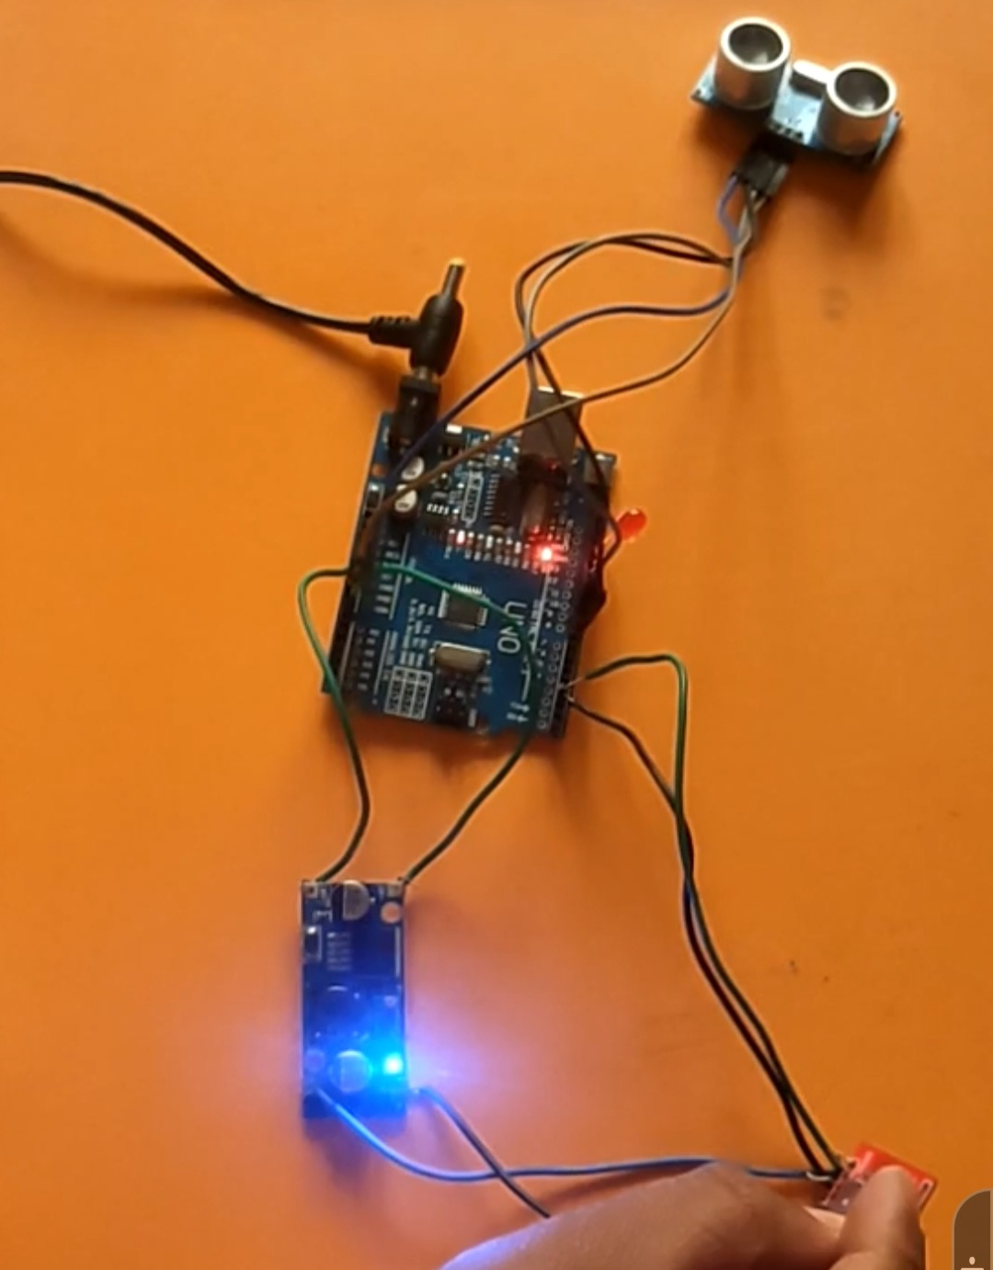
and the suspension of services for media platforms Such as twitter and Netflix.

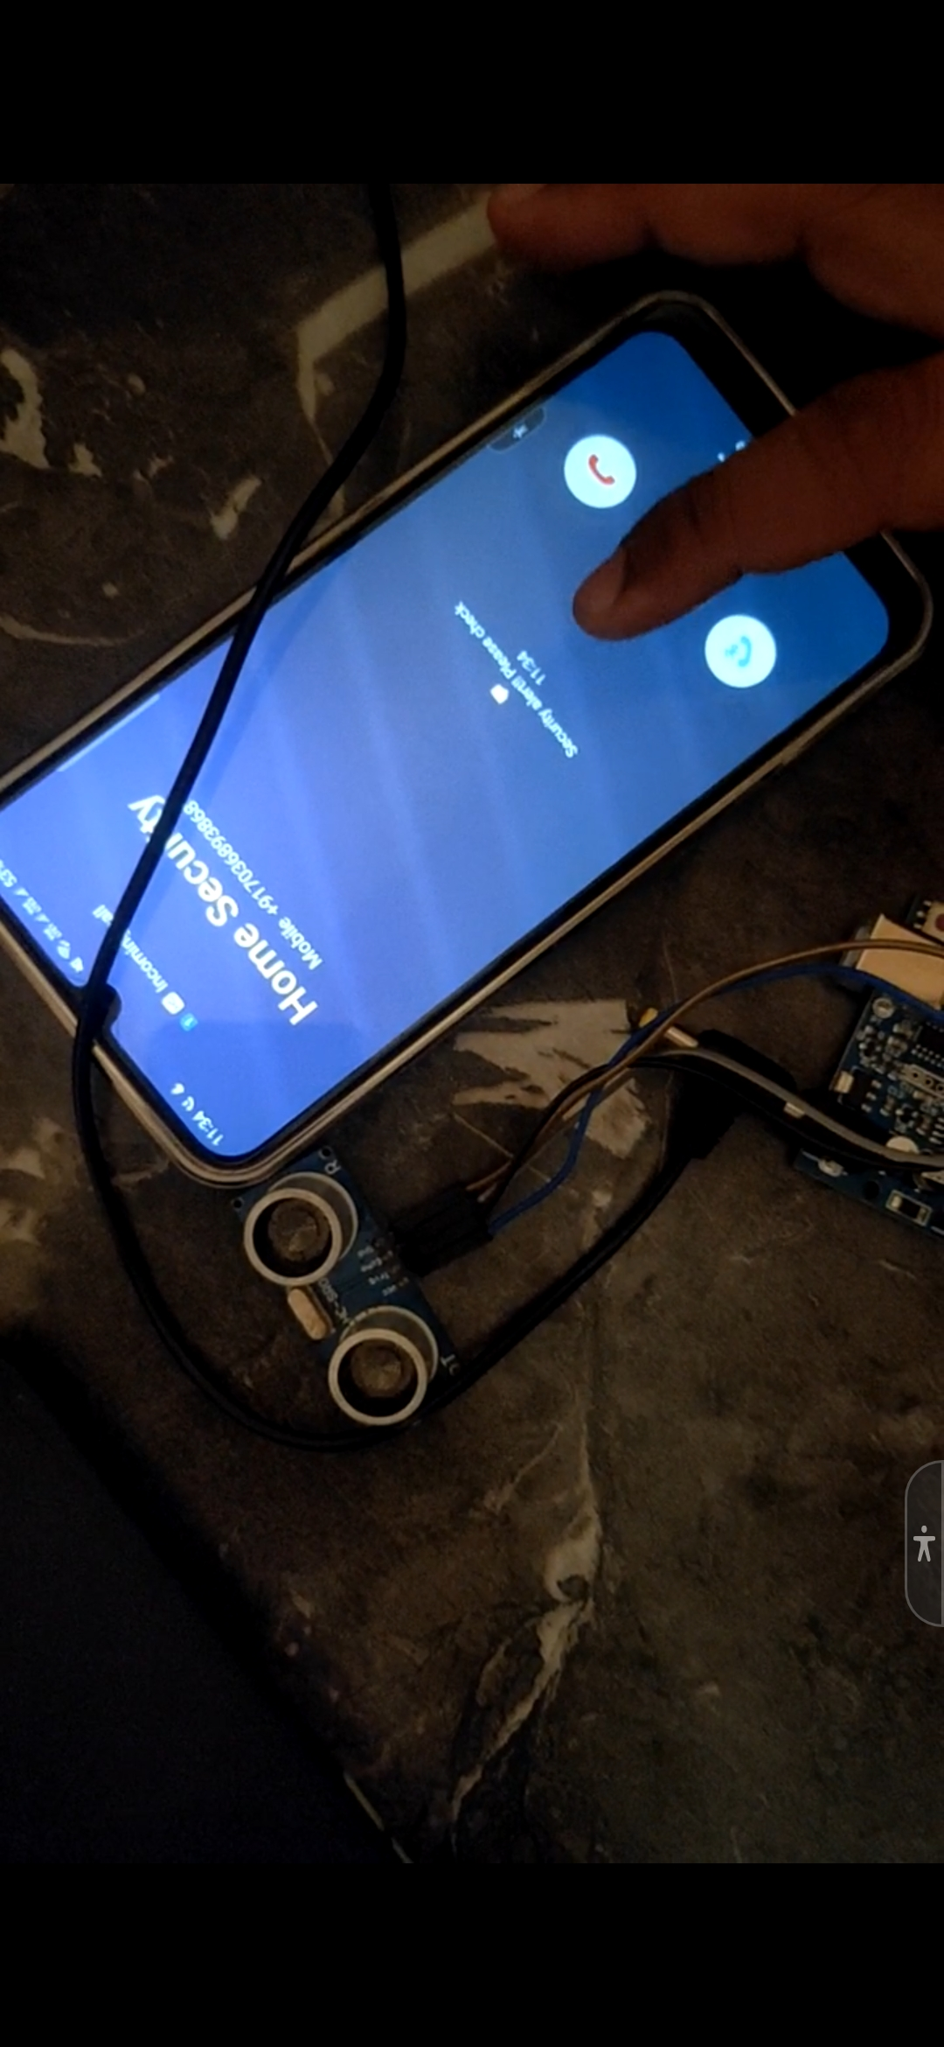

References
- A Novel Method To Solve Visual Tracking Problem: Hybrid Algorithm Of Grasshopper Optimization Algorithm And Differential Evolution Evolutionary Intelligence, 2022, 15(1), Pp. 785–822
- Polaiah Bojja Etal; Experimental Analysis And Improvements Of A Visible Spectro Photometer Fordetection Of Nano Materials”,International Journal Of Chemical Engineering, April, 22
- Polaiah Bojja Etal, “A Novel Method To Solve Visual Tracking Problem: Hybrid Algorithm Of Grass Hopper Optimization Algorithm And Differential Evolution, Evolutionary Intelligence,2021
- Polaiah Bojja, Etal, A Novel Method To Solve Visual Tracking Problem: Hybrid Algorithm Of Grass Hopper Optimization
- Algorithm And Differential Evolution- [Emid: 6e7b1b6195f4b6c0], Springer, Journal Of Evolutionary Intelligence, Doi: 10.1007/S12065-021-00567-0, Jan2021.
- https://www.researchgate.net/publication/332835074_Research_Paper_On_Home_Automation_Using_Arduino
- https://www.researchgate.net/publication/332578743_Web_Based_Home_Security_and_Automation_System
- Gorla Hampika, Vodela Rohit, P. Abhishek & Guduri Manisha ,”Design of Drunk and Drive Detection Device”, CCSN2019, Springer, Vol 664 , pp: 315-323,2020.
- https://ieeexplore.ieee.org/document/8821885
- https://www.ripublication.com/ijaer18/ijaerv13n2_57.pdf
- https://acadpubl.eu/hub/2018-119-15/5/801.pdf
- https://www.academia.edu/25030686/Design_and_Implementation_of_Security_Systems_for_Smart_Home_based_on_GSM_technology
- https://www.academia.edu/36782305/Review_On_Home_Security_System
- https://iopscience.iop.org/article/10.1088/1742-6596/953/1/012128/pdf
- https://www.technicaljournalsonline.com/ijeat/VOL%20II/IJAET%20VOL%20II%20ISSUE%20IV%20%20OCTBER%20DECEMBER%202011/ARTICLE%2066%20IJAET%20VOLII%20ISSUE%20IV%20OCT%20DEC%202011.pdf

